Eamcet 2005 Solved Paper

This practice EAMCET solved question papers is designed to prepare you for the EAMCET 2011 Exam. Find the information related to EAMCET 2011 Notification, EAMCET Key.
Names of units of some physical quantities are given in List – I and their dimensions formulae are given in List – II. Match the correct pairs in the list-II. Match the correct pairs in the lists:
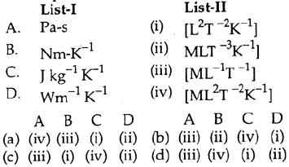
A. ( a)
B. ( b)
C. ( c)
D. ( d)
At a given instant of time the position vector of a particle moving in a circle with a velocity is its angular velocity at that time is :
A. 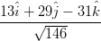
B. 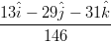
C.
D. 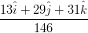
A body projected vertically upwards crosses a point twice in its journey at a height h just after and seconds. Maximum height reached by the body is :
A. 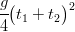
B. 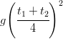
C. 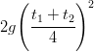
D. 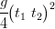
The equation of trajectory of a projectile is 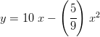
If we assume the range of projectile (in metre) is :
A. 36
B. 24
C. 18
D. 9
The machine gun fires 240 bullet per minute. If the mass of each bullet is 10 g and the velocity of the bullets is the power (in kW) of the gun is :
A. 43200
B. 432
C. 72
D. 7.2
The centre of mass of three particle of masses 1 kg, 2 kg and 3 kg is at (2, 2, 2). The position of the fourth mass of 4 kg to be placed in the system as that the news centre of mass is at (0, 0, 0) is :
A. (-3, -3, -3)
B. (-3, 3, -3)
C. (2, 3, -3)
D. (2, -2, 3)
Consider the following statement A and B and identify the correct answer :
(A): In an elastic collision, if a body suffers a head on collision with another of same mass at rest, the first body comes to rest, while the others starts moving with the velocity of the first one.
(B): Two bodies of equal masses suffering a head on the elastic collision merely exchanges their velcities :
A. both A and B are true
B. both A and B are false
C. A is true but B is false
D. A is false but B is true
The minimum force required to move a body up an inclined plane is three times the minimum force required to prevent it from sliding down the plane. if the coefficient of friction between the body and the inclined plane is 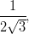the angle of inclined plane is :
A.
B.
C.
D.
The instantaneous velocity of a point B of the given rod pf length of 0.5 m is 3 m/s in the represented direction. The angular velocity of the rod for minimum velocity of end A is :
A. 1.5 rad / s
B. 5.2 rad / s
C. 2.5 rad / s
D. none of these
Identify the increasing order of the angular velocities of the following :
1. earth rotating about its own axis
2. hour’s hand of a clock
3. second’s hand of a clock
4. flywheel of radius 2 m, making 300 rpm
A. 1, 2, 3, 4
B. 2, 3, 4, 1
C. 3, 4, 1, 2
D, 4, 1, 2, 3
Degenerate electron pressure will not be sufficient to prevent core collapse of ‘white dwarf’ if its mass becomes n times of solar mass. Value of n is :
A. 0.5
B. 0.8
C. 1
D. 1.4
A body of mass m is suspended to an ideal spring of force constant k. the expected change position of the body due to an additional force F acting vertically downwards is :
A.
B.
C.
D.
The radii and Young’s moduli of two uniform wires A and B are in the ratio 2 : 1 and 1 : 2 respectively. Both wires are subjected to the same longitudinal force. If the increase in length of the wire A is one percent, the percentage increase in length of the wire B is :
A. 1.0
B. 1.5
C. 2.0
D. 3.0
The heat evolved for the rise of water when one end of the capillary tube of radius r is immersed vertically into water is: (Assume surface tension = T and density of water to be )
A.
B.
C. 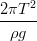
D. None of these
An iron sphere of mass falls through a viscous liquid with terminal velocity The terminal velocity (in ) of another iron sphere of mass kg is :
A. 4.5
B. 3.5
C. 2.5
D. 1.5
The relation between the coefficient of real expansion and coefficient of apparent expansion of liquid and the coefficient of linear expansion of the material of container is :
A.
B.
C.
D.
The differences between volume and pressure coefficient of an ideal gas is :
A.
B. 273
C.
D. Zero
The ratio of specific heats of a gas is The change in internal energy of one mole of the gas, when the volume changes from V to 2V at constant pressure P is :
A. 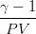
B. PV
C. 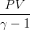
D.
The tyre of motor car contains air at If the temperature increases to the approximate percentage increase in pressure is (ignore to expansion of tyre) :
A. 7
B. 9
C. 11
D. 13
Two identical bodies have temperature and If the surroundings temperature is the ratio of loss of heats of the two bodies during the same interval of time is (approximately) :
A. 4 : 1
B. 8 : 1
C. 12 : 1
D. 19 : 1
A vehicle sounding a whistle of frequency 256 Hz is moving on a straight road, towards a hill with a velocity of The number of beats per second observed by a person travelling in the vehicle is : (Velocity of sound = )
A. Zero
B. 10
C. 14
D. 16
A transverse wave propagating on a stretched string of linear density is represented by the equation where x is in metres and t is in seconds. The tension in the string (in newton) is:
A. 0.24
B. 0.48
C. 1.20
D. 1.80
Assertion (A) : Propagation of light through an optical fibre is due to total internal reflection taking place at the core-clad interface.
Reason ( R) : Refractive index of the material of the core of the optical fibre is greater than that of air.
A. Both (A) and ( R) are true and ( R) is the correct explanation of (A)
B. Both (A) and ( R) are true but ( R) is not the correct explanation of (A)
C. (A) is true but ( R) is false
D. (A) is false but ( R) is true
The focal length of an equi-convex lens is greater than the radius of curvature of any of the surfaces. Then the refractive index of the material of the lens is :
A. Greater than zero but less than 1.5
B. Greater than 1.5 but less than 2.0
C. Greater than 2.0 but less than 2.5
D. Greater than 2.5 but less than 2.0
Fraunhofer lines are produced by the obsorption of light in :
A. The chromosphere of the sun
B. The photosphere of the sun
C. Sodium
D. Hydrogen
A light ray of wavelength is passing through a pin hole of diameter D and the effect is observed on a screen placed at a distance L from the pin hole. The approximations of geometrical optics are applicable if :
A.
B. 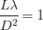
C. 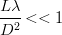
D. 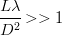
With a standard rectangular bar magnet of length (l), breadth (b ; b < < l) and magnetic moment M, the time period of the magnetometer is 4 s. If the magnet is cut normal to its length into four equal pieces, the time period (in seconds) with one of the pieces is :
A. 16
B. 2
C. 1
D. 1/4
If two identical bar magnets, each of length l, pole strength m and magnetic moment M are placed perpendicular to each other with their unlike poles in contact, the the magnetic moments of the combination is :
A.
B.
C.
D. 2M
A 4 capacitor is charged by 200 V battery. it is then disconnected from the supply and is connected to another uncharged 2 capacitor. During the process, loss of energy (in J) is :
A.
B.
C.
D.
Two charges 2 C and 6 C are separated by a finite distance. If a charge of -4 C is added to each of them, the initial force of will change to :
A. (repulsion)
B. (repulsion)
C. (attraction)
D. (attraction)
A 6 V cell with 0.5 internal resistance, a 10 V cell with internal resistance and a external resistance are connected in parallel. The current (in ampere) through the 10 V cell is :
A. 0.60
B. 2.27
C. 2.87
D. 5.14
In a meter bridge a resistance is connected in the left gap and a pair of resistances P and Q in the right gap. Measured from the left, the balance point is 37.5 cm, when P and Q are in series and 714 cm when they the parallel. the values of P and Q are :
A. 40 10
B. 35 15
C. 30 20
D. 25 25
Consider the following statements A and B and identify the correct answers given below :
A : Peltier coefficient is numerically equal to the potential differences across the junctions of the thermocouple through which current is following.
B : According to Thomson, energy is neither absorbed nor evolved only along the lengths of both the conductors.
A. Both A and B are true
B. Both A and B are false
C. A is true but B is false
D. A is false but B is true
An inductance 1 H is connected in series with an AC source of 220 V and 50 Hz. The inductive reactance (in ohm) is :
A.
B.
C.
D.
Two parallel rails of the railway track insulated from each other and with the ground are connected to a millivoltmeter. The distance between the rails is one metre. A train is travelling with a velocity of 72 km/h along the track. The reading of the milivoltmeter (in mV) is : (Vertical component of the earth’s magnetic induction is )
A. 1.44
B. 0.72
C. 0.4
D. 0.2
Magnetic field induction at the centre of a circular coil of radius 5 cm and carrying a current 0.9 A is (in SI units)
( absolute permittivity of air in SI units; velocity of light )
A. 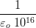
B.
C.
D.
A particle of mass and charge travelling with a velocity along the positive X-axis enters a region in which a uniform electric field and a uniform magnetic filed of induction are present. If and the direction of motion of the particles is :
A. Along the positive X-axis
B. Along the negative X-axis
C. At to positive X-axis
D. At to positive X-axis
Particles and their anti-particles have:
A. The same masses but opposite spins
B. The same masses but opposite magnetic moments
C. The same masses and same magnetic moments
D. Opposite spins and some magnetic moments
An n-p-n transistor power amplifier in C-E configuration gives:
A. voltage amplification only
B. currents amplification only
C. both current and voltage amplifications
D. only power gain of unity
In Fischer-Ringe’s method of separation of nobles gas mixture from air, ........... is used :
A.
B. coconut charcoal
C. soda lime + potash solution
D. urea
A complex compounds of with molecular formula gives a total of 3 ions when dissolved in water. How many ions satisfy both primary and secondary valencies in this complex ?
A. 3
B. 1
C. 4
D. zero
The chemicals and the reaction conditions required for the preparation of ethane are :
A.
B.
C. electrolysis
D.
Observe the following statements regarding purification of bauxite :
I. During Hall’s process, silica is removed as Si (vapour)
II. Bauxite ore contaminated with is purified in Baeyer’s process.
III. During Serpeck’s process, AlN is formed.
The correct answer is
A. I, II and III are correct
B. Only I and II are correct
C. Only I and III are correct
D. Only II and III are correct
Sodium is heated in air at to form X,X absorbs and forms and Y Which of the following is Y ?
A.
B.
C.
D.
Identify A and B in the following reactions :
A.
B.
C.
D.
Which one of the following reactions does not form gaseous product ?
A.
B. Acidified
C.
D.
Which of the following is an example for heterogeneous catalysis reaction ?
A.
B. Hydrolysis of aqueous sucrose solution in the presence of aqueous minerals acid
C.
D. Hydrolysis of liquid in the presence of aqueous minerals acid
In which of the following reaction the product is an ether ?
A.
B.
C.
D.
The atomic numbers of elements X, Y and Z are 19, 21 and 25 respectively. The number of electrons present in the M Shell of these elements follow the order :
A. Z > X > Y
B. X > Y > Z
C. Z > Y > X
D. Y > Z > X
Which of the following, Compounds is the reactant in Rosenmund’s reduction ?
A.
B.
C.
D.
An electron is moving in Bohr’s fourth orbit. Its de-Broglie wave length is What is the circumference of the fourth orbit ?
A.
B.
C.
D.
The half-lives of two radioactive nuclides A and B are 1 and 2 min respectively. Equal weights of A and B are taken separately and allowed to disintegrate for 4 min. What will be the radio of weight of A and B disintegrated ?
A. 1 : 1
B. 5 : 4
C. 1 : 2
D. 1 : 3
3-hydroxybutanal is formed when (X) reacts with (Y) in dilute (Z) solution. What are X,Y and Z ?
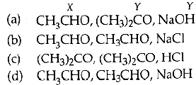
A. ( a)
B. ( b)
C. ( c)
D. ( d)
Identify the correct order in which the covalent radius of the following elements increases :
(I) Ti
(II) Ca
(III) Sc
A. (I), (II), (III)
B. (III), (II), (I)
C. (II), (I), (III)
D. (I), (III), (II)
Which of the following is a linear molecule ?
A.
B.
C.
D.
‘Natalite’ is used as :
A. Anaesthetic
B. substitute for petrol
C. insecticide
D. preservative
Which of the following is correct ?
A. The number of electrons present in the valence shell of S in is 12
B. The rates of ionic reactions are very slow
C. According to VSEPR theory, is a linear molecule
D. The correct order of ability to forms ionic compounds among and is
x grams of calcium carbonate was completely burnt in air. The weight of the solid reside formed is 28 g. What is the value of x (in grams) ?
A. 44
B. 200
C. 150
D. 50
In reaction.
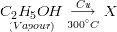
The molecular formula of X is :
A.
B.
C.
D.
A and B are ideal gases. The molecular weights of A and B are in the ratio of 1 : 4. The pressure of a gas mixture containing equal weight of a gas mixture containing equal weight of A and B is P atm. What is the partial pressure (in atm) of B in the mixture ?
A.
B.
C.
D.
The vapour pressure of water at is 19.8 mm. 0.1 mole of glucose is dissolved in 178.2 g of water. What is the vapour pressure (in mm) of the resultant solution?
A. 19.0
B. 19.602
C. 19.402
D. 19.202
Which of the following is not correct ?
A. Chlorophyll is responsible for all the synthesis of carbohydrates in plants
B. The compounds formed in the addition of oxygen to hemoglobin is called oxyhaemoglobin
C. Acetyl salicylic acid is known as aspirin
D. The metal ion present in vitamin is
Assertion (A) : The pH of a buffer solution containing equal moles of acetic acid and sodium acetate is 4.8 ( of acetic acid is 4.8).
Reason ( R) : the ionic product of water at is
The correct answer is :
A. Both (A) and ( R) are true and ( R) is the correct explanation of (A)
B. Both (A) and ( R) are true and ( R) is not the correct explanation of (A)
C. (A) is true but ( R) is not true
D. (A) is not true but ( R) is true
What is the quantity of electricity (in Coulombs) required to deposit all the silver from 250 mL of 1 M solution ?
A. 2412.5
B. 24125
C. 4825.0
D. 48250
Which of the following is not an air pollutant ?
A.
B.
C.
D.
Which of the following is not correct ?
A. Aqueous solution of is an electrolyte
B. The units of electrochemical equivalent are g- Coulomb
C. In the Nernst equation, represent the number of electrons transferred in the electrode reaction
D. Standard reduction potential of hydrogen electrode is zero volt
Observe the following reaction :
The rate of information of C is What is the value of 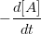(in ) ?
A.
B.
C.
D.
Which of the following compounds is soluble in benzene but almost insoluble in water?
A.
B.
C.
D.
At 550 K, the for the following reaction is
At equilibrium, it was observed that : 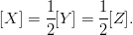
What is the value of [Z] (in mol ) at equilibrium ?
A.
B.
C.
D.
Which of the following is not correct ?
A. Dissolution of in excess of water is an endothermic process
B. Nautralisation process is always exothermic
C. The absolute value of enthalpy (H) can be determined experimentally
D. The heat of reaction at constant volume is denoted by
Which of the following is a pair of functional isomers ?
A.
B.
C.
D.
The pH of a solution of is 6.0. Some chlorine gas is bubbled into this solution. Which of the following is correct ?
A. The pH of resultant solution becomes 8.0
B. Hydrogen gas is liberated from the resultant solution
C. The pH of resultant solution becomes less than 6.0 and oxygen gas is liberated
D. is formed in the resultant solution
In which of the following reactions, MgO is not formed ?
A.
B.
C.
D.
The compound prepared by a substitutions reaction of benzene is :
A. acetophenone
B. glyoxal
C. cyclohexane
D. hexabromo cyclohexane
Which of the following is not correct ?
A. is used as acid flux
B. The distance between the layers in graphite is
C. reacts with and liberates CO.
D. The hybridisation of C in graphic is
Which of the following is not correct ?
A. Ammonia is used as refrigerant
B. A mixture of and C is known as nitrolim
C. A mixture of and is known as super phosphate of lime
D. Hydrolysis of gives and
Match the following lists :
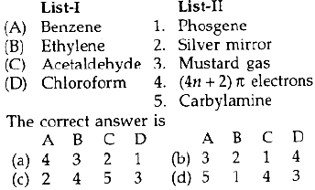
A. ( a)
B. ( b)
C. ( c)
D. ( d)
Which of the following is not correct ?
A. Iodine oxidises sodium thiosulphate to sodium tetrathionate
B. Sodium thiousulphate is soluble in water
C. Ozone is used to identify the presence of unsaturation in alkenes
D. Sodium thiosulphate reacts with iodine to form sodium sulpahte
Which one of the following pairs of reactants does not form oxygen when they react with each other ?
A. solution (hot, conc.)
B.
C. solution (cold, dilute)
D. (dilute, small, amount)
is equal to :
A. R, the set of all real numbers
B. the empty set
C.
D.
The function defined by 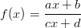for where reduces to a constant functions, if :
A. a = c
B. b = d
C. ad = bc
D. ab = cd
If n denotes the set of all positives integers and if is defined by f(n) = the sum of positive divisors of n then, where k is a positives integers, is :
A.
B.
C.
D.
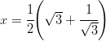then 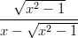is equal to :
A. 1
B. 2
C. 3
D.
If and belong to the set then
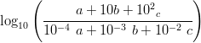is equal to :
A. 1
B. 2
C. 3
D. 4
A.
B.
C.
D.
A three digit number n is such that the last two digits of it are equal and differ from the first. the number of such n’s is :
A. 64
B. 72
C. 81
D. 900
If then 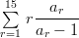is equal to :
A. 110
B. 115
C. 120
D. 135
The coefficient of in the expansion of is :
A. 70
B. 60
C. 50
D. None of these
If 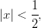then the coefficient of in the expansion of 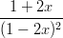is :
A.
B.
C.
D.
If 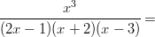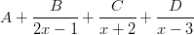then A is equal to :
A.
B.
C.
D.
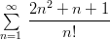is equal to :
A. 2e – 1
B. 2e + 1
C. 6e – 1
D. 6e + 1
If 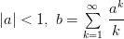then a is equal to :
A. 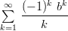
B. 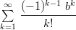
C. 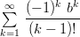
D. 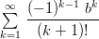
If x is real, then the minimum value of 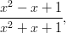is :
A.
B. 3
C.
D. 1
if is a root of
if are the roots of
Which of the following is true ?
A. is true, is true
B. is true, is false
C. is false, is true
D. is false, is false
The roots of the equation are :
A. -1, -1, 2
B. -1, 1, -2
C. -1, 2, -3
D. -1, -1, -2
If are the roots of then
A. 12
B. 13
C. 14
D. 15
If then 3m + 7n is equal to :
A. 3
B. 5
C. 10
D. 1
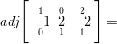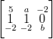then is equal to :
A.
B.
C.
D.
If then is equal to :
A. 2A
B. 2i
C. A
D. i
If respectively denote the moduli of the complex number 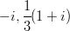and then their increasing order is :
A.
B.
C.
D.
If is non-real roots of then 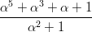is equal to :
A.
B. 0
C.
D.
If then is equal to :
A.
B. 0
C.
D.
The extreme values of 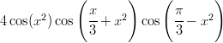over R, are :
A. -1, 1
B. -2, 2
C. -3, 3
D. -4, 4
If 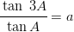then 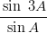is equal to :
A. 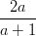
B. 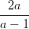
C. 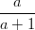
D. 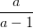
If A + C = 2B then 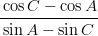is equal to :
A. cot B
B. cot 2B
C. tan 2B
D. tan B
is equal to :
A. 1
B. 2
C. 0
D. 3
If 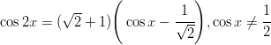then
A. 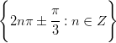
B. 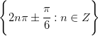
C. 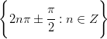
D. 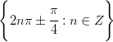
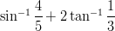is equal to :
A.
B.
C.
D. 0
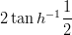is equal to :
A. 0
B.
C.
D.
In a is equal to :
A. a
B. b
C. c
D. a+b+c
In a 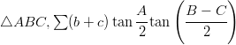is equal to :
A. a
B. b
C. c
D. 0
Two side of a triangle are given by the equation and the angle between the sides is Then the perimeter of the triangle is :
A.
B.
C.
D.
A tower, of x metres high, has a flagstaff at its top. The tower and the flagstaff subtend equal angles at a point distant y metres from the foot of the tower. Then the length of the flagstaff (in metres), is :
A. 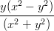
B. 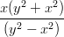
C. 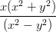
D. 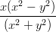
If the vector and are collinear and then is equal to :
A.
B.
C.
D.
If and are unit vectors, then the victors is parallel to the vector:
A.
B.
C.
D.
I : Two non-zero, non-collinear vectors are linearly independent.
II : Any three coplanar vectors are linearly dependent.
Which of the above statement is/are true ?
A. Only I
B. Only II
C. Both I and II
D, Neither I nor II
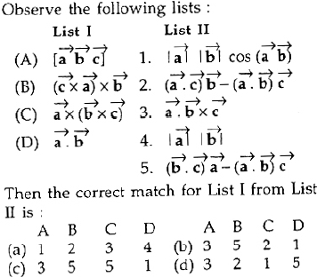
A. ( a)
B. ( b)
C. ( c)
D. ( d)
Observe the following statements :
A : Three vectors are coplanar if one of them is expressible as a linear combination of the other two.
R : Any three coplanar vectors are linearly dependent.
Then which of the following is true ?
A. Both A and R are true and R is correct explanation of A
B. Both A and R are true but R is not correct explanation of A
C. A is true, but R is false
D. A is false, but R is true
A coin and six faced die, both unbiassed, are thrown simultaneously. The probability of getting a head on the coin and the odd number on the die, is :
A.
B.
C.
D.
A number n is chosen at random from
Let
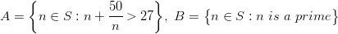and Then correct order of their probabilities is :
A. P (A) < P (B) < P ( C)
B. P (A) > P (B) > P ( C)
C. P (B) < P (A) < P ( C)
D. P (A) > P ( C) > P (B)
Box A contains 2 black and 3 red balls, while Box B contains 3 black and 4 red balls. Out of these two boxes one is selected at random ; and the probability of choosing Box A is double that of Box B. If a red ball is drawn from the selected box, then the probability that it has come from Box B, is
A.
B.
C.
D.
If the range of a random variable X is with 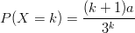for then a is equal to :
A.
B.
C.
D.
For a binomial variate X with n = 6, if P(X = 2) = 9 P(X = 4), then its variance is :
A.
B.
C.
D. 4
If the point P moves such that its distances from the point A (1, 1) and the line x + y + 2 = 0 are equal, then the locus of P is :
A. a straight line
B. a pair of straight lines
C. a parabola
D. an ellipse
The area (in square units) of the triangle formed by the lines x = 0, y = 0 and 3x + 4y = 12, is :
A. 3
B. 4
C. 6
D. 12
If PM is the perpendicular from P (2, 3) onto the line x + y = 3, then the co-coordinates of M are :
A. (2, 1)
B. (-1, 4)
C. (1, 2)
D. (4, -1)
The equation of the straight line perpendicular to and passing through the point of intersection of the lines and is :
A.
B.
C.
D.
The area of the triangle formed by the pair of straight lines
and is :
A. 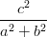
B. 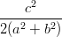
C. 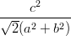
D. 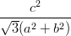
The product of the perpendicular distances from the origin on the pair of straight lines is :
A.
B.
C.
D.
The direction cosines of the line passing through P (2, 3, -1) and the origin are :
A. 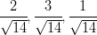
B. 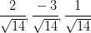
C. 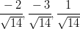
D. 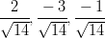
The point collinear with (1, -2, -3) and (2, 0, 0) among the following is :
A. (0, 4, 6)
B. (0, -4, -5)
C. (0, -4, -6)
D. (0, -4, 6)
The equation of the circle whose diameter is the common chord of the circles
and is :
A.
B.
C.
D.
If meets the circle at A and B, then the equation of the circle with AB as diameter is :
A.
B.
C.
D.
If y = 3x is a tangent to a circle with centre (1, 1), then the other tangent drawn through (0, 0) to the circle is :
A. 3y = x
B. y = -3x
C. y = 2x
D. y = -2x
The parabola with directrix and focus (1, 0) is :
A.
B.
C.
D.
The line among the following which touches the parabola is :
A.
B.
C.
D.
The cartesian form of the polar equation is :
A. x = 2y
B. y = 2x
C. x = 4y
D. y = 4x
Which of the following equations gives a circle ?
A.
B.
C.
D.
is equal to :
A. 1
B. 0
C. does not exist
D.
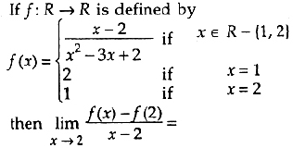
A. 0
B. -1
C. 1
D.
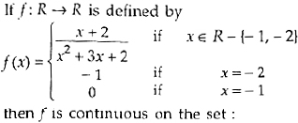
A. R
B. R – [-2]
C. R – [-1]
D. R – [-1, -2]
If is an even function which is twice differentiable on R and then is equal to :
A. -1
B. 0
C. 1
D. 2
Observe the following statements :
I. 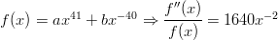
II. 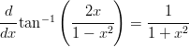
Which of the following is correct ?
A. I is true, but II is false
B. Both I and II are true
C. Neither I nor II is true
D. I is false, but II is true
If then is equal to :
A.
B.
C.
D.
If then is equal to :
A. 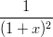
B. 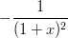
C. 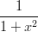
D. 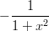
A stone thrown upwards, has its equations of motion Then the maximum height reached by it, is :
A. 24500
B. 12500
C. 12250
D. 25400
The radius of a circular plate is increasing at the rate of 0.01 cm/sec when the radius is 12 cm. Then at the rate at which the area increase, is :
A.
B.
C.
D.
Observe the following statements :
is increasing outside the interval (1, 2)
for
Then which of the following is true ?
A. Both A and R are true, and R is not the correct reason for A
B. Both A and R are true, and R is the correct reason for A
C. A is true, but R is false
D. A is false, but R is true
If 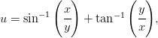then the value of 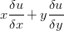is :
A. 0
B. 1
C. 2
D. None of these
If 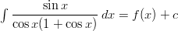then is equal to :
A. 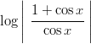
B. 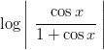
C. 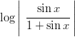
D. 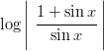
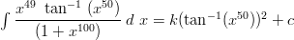then k is equal to :
A.
B.
C.
D. 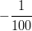
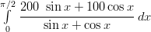is equal to :
A.
B.
C.
D.
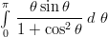is equal to :
A.
B.
C.
D.
If 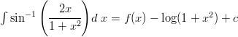then f(x) is equal to :
A.
B.
C.
D.
The area (in square units) bounded by the curves and in the plane is :
A.
B.
C.
D.
If then is equal to :
A.
B.
C.
D.
If 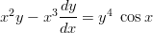then is equal to :
A.
B.
C.
D.
Observe the following statements :
I. If then
II. If then
Which of the following is a correct statement ?
A. Both I and II are true
B. Neither I nor II is true
C. I is true, II is false
D. I is false, II is true
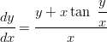then is equal to :
A.
B.
C.
D.

